21-7-26 QUERY PROCESSING FOR DATA SCIENCE SIDDARTH.P
5.Write a Pandas program to create a bar plot of the trading volume of Alphabet Inc.
stock between two specific dates.
Date | Open | High | Low | Close | Volume
2016-10-03 | 774.25 | 776.06 | 769.50 | 772.55 | 1500000
2016-10-04 | 776.03 | 778.71 | 772.89 | 776.42 | 1400000
2016-10-05 | 779.30 | 782.07 | 775.65 | 776.46 | 1300000
2016-10-06 | 779.00 | 780.47 | 775.53 | 776.85 | 1200000
2016-10-07 | 779.65 | 779.65 | 770.75 | 775.08 | 1100000

Code:
import pandas as pd
import matplotlib.pyplot as plt

df = pd.read_csv("alphabet_stock_data.csv", parse_dates=['Date'])
data = df[(df['Date'] >= '2016-10-03') & (df['Date'] <= '2016-10-07')]

plt.bar(data['Date'], data['Volume'])
plt.xlabel("Date")
plt.ylabel("Volume")
plt.title("Alphabet Trading Volume")
plt.xticks(rotation=45)
plt.show()

Output:
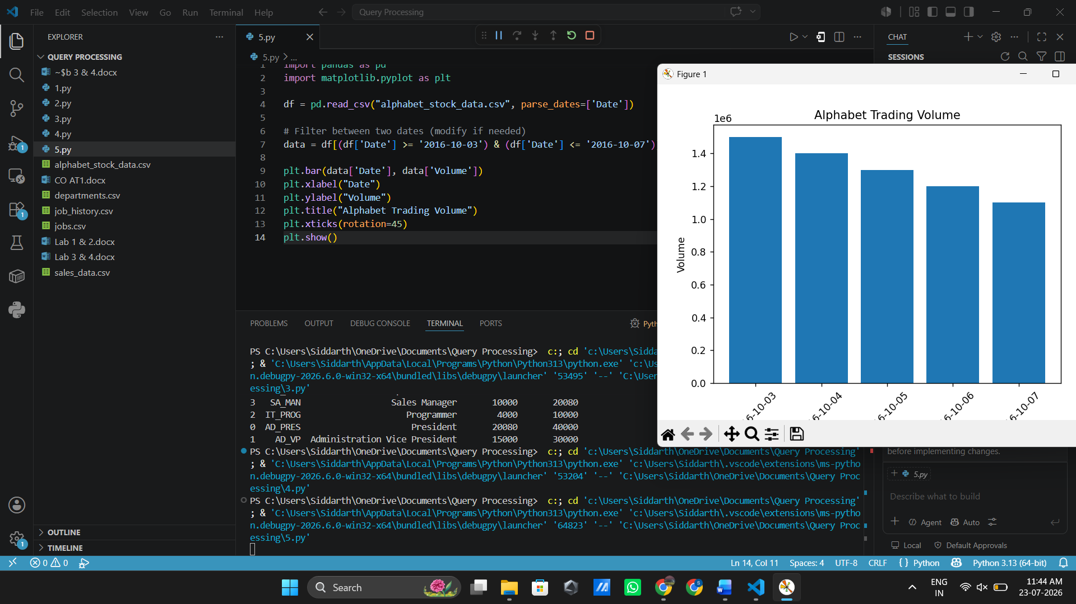

6.Write a Pandas program to create a scatter plot of the trading volume/stock prices of
Alphabet Inc. stock between two specific dates.
Date | Open | High | Low | Close | Volume
2016-10-03 | 774.25 | 776.06 | 769.50 | 772.55 | 1500000
2016-10-04 | 776.03 | 778.71 | 772.89 | 776.42 | 1400000
2016-10-05 | 779.30 | 782.07 | 775.65 | 776.46 | 1300000
2016-10-06 | 779.00 | 780.47 | 775.53 | 776.85 | 1200000
2016-10-07 | 779.65 | 779.65 | 770.75 | 775.08 | 1100000

Code:
